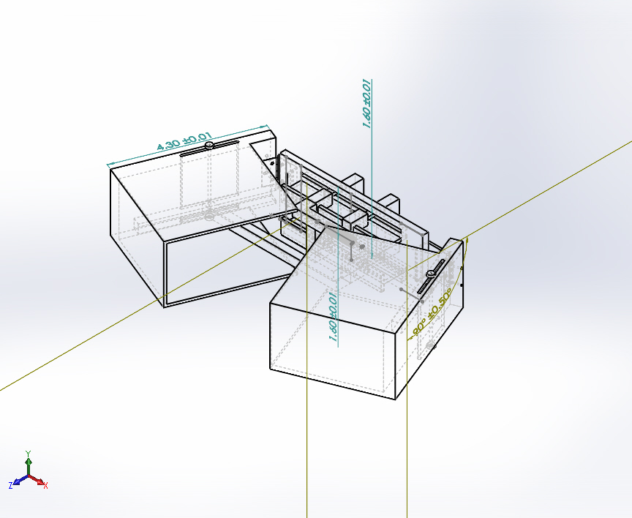 | Simulation of Assem1.1 (5) (1)  Date: Sunday, April 19, 2020  Designer: Solidworks  Study name: Nonlinear Stainless With Teflon Sliding Parts  Analysis type: Nonlinear - Dynamic  Table of Contents  Description 1  Assumptions 2  Model Information 2  Study Properties 8  Units 8  Material Properties 9  Loads and Fixtures 11  Connector Definitions 12  Contact Information 12  Mesh information 13  Sensor Details 14  Resultant Forces 15  Beams 15  Study Results 16  Conclusion 18

Description
No Data

Assumptions

Model Information

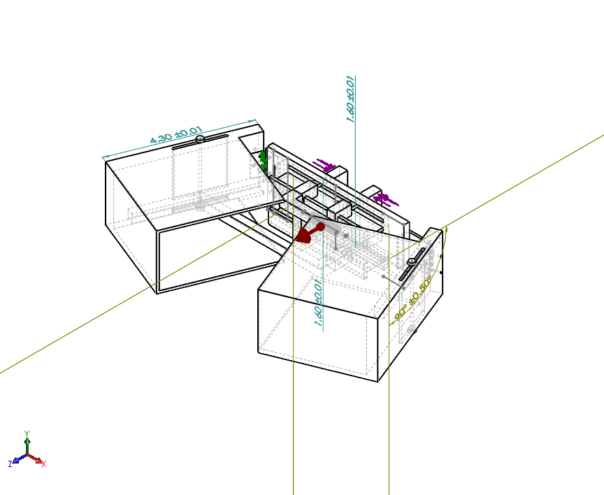
Model name: Assem1.1 (5) (1)
Current Configuration: Default
Solid Bodies
Document Name and Reference | Treated As | Volumetric Properties | Document Path/Date Modified
Cut-Extrude1 | Solid Body | Mass:0.00042762 kg  Volume:5.48231e-08 m^3  Density:7,800 kg/m^3  Weight:0.00419068 N | C:\Users\jvd4618\Downloads\Part1hingefolder.SLDPRT  Apr 18 22:45:58 2020
Cut-Extrude1 | Solid Body | Mass:0.00042762 kg  Volume:5.48231e-08 m^3  Density:7,800 kg/m^3  Weight:0.00419068 N | C:\Users\jvd4618\Downloads\Part1hingefolder.SLDPRT  Apr 18 22:45:58 2020
Chamfer1 | Solid Body | Mass:0.000210181 kg  Volume:2.69463e-08 m^3  Density:7,800 kg/m^3  Weight:0.00205977 N | C:\Users\jvd4618\Downloads\Part2hingebolt.SLDPRT  Apr 18 22:45:58 2020
Cut-Extrude1 | Solid Body | Mass:0.00042762 kg  Volume:5.48231e-08 m^3  Density:7,800 kg/m^3  Weight:0.00419068 N | C:\Users\jvd4618\Downloads\Part1hingefolder.SLDPRT  Apr 18 22:45:58 2020
Cut-Extrude1 | Solid Body | Mass:0.00042762 kg  Volume:5.48231e-08 m^3  Density:7,800 kg/m^3  Weight:0.00419068 N | C:\Users\jvd4618\Downloads\Part1hingefolder.SLDPRT  Apr 18 22:45:58 2020
Chamfer1 | Solid Body | Mass:0.000210181 kg  Volume:2.69463e-08 m^3  Density:7,800 kg/m^3  Weight:0.00205977 N | C:\Users\jvd4618\Downloads\Part2hingebolt.SLDPRT  Apr 18 22:45:58 2020
Boss-Extrude2  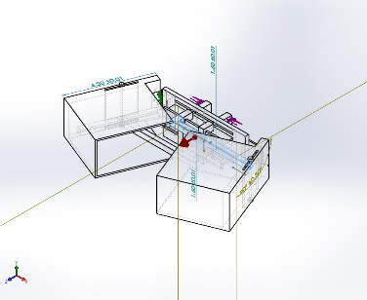 | Solid Body | Mass:0.014385 kg  Volume:6.20042e-06 m^3  Density:2,320 kg/m^3  Weight:0.140973 N | C:\Users\jvd4618\Downloads\Bar (3).SLDPRT  Apr 18 22:45:58 2020
Boss-Extrude2  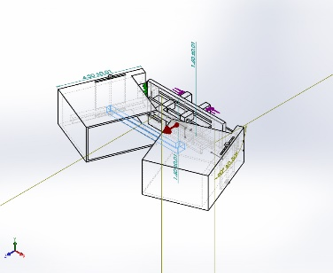 | Solid Body | Mass:0.014385 kg  Volume:6.20042e-06 m^3  Density:2,320 kg/m^3  Weight:0.140973 N | C:\Users\jvd4618\Downloads\Bar (3).SLDPRT  Apr 18 22:45:58 2020
Cut-Extrude1 | Solid Body | Mass:0.000456216 kg  Volume:1.96645e-07 m^3  Density:2,320 kg/m^3  Weight:0.00447092 N | C:\Users\jvd4618\Downloads\Correct Dimensions Gripper Part Sliding Pole Attached to Top Block (1) (2).SLDPRT  Apr 18 22:45:58 2020
Cut-Extrude1 | Solid Body | Mass:0.000456216 kg  Volume:1.96645e-07 m^3  Density:2,320 kg/m^3  Weight:0.00447092 N | C:\Users\jvd4618\Downloads\Correct Dimensions Gripper Part Sliding Pole Attached to Top Block (1) (2).SLDPRT  Apr 18 22:45:58 2020
Boss-Extrude1 | Solid Body | Mass:0.00912432 kg  Volume:3.9329e-06 m^3  Density:2,320 kg/m^3  Weight:0.0894183 N | C:\Users\jvd4618\Downloads\JazzBlock.SLDPRT  Apr 18 22:45:58 2020
Cut-Extrude1 | Solid Body | Mass:0.000456216 kg  Volume:1.96645e-07 m^3  Density:2,320 kg/m^3  Weight:0.00447092 N | C:\Users\jvd4618\Downloads\Correct Dimensions Gripper Part Sliding Pole Attached to Top Block (1) (2).SLDPRT  Apr 18 22:45:58 2020
Cut-Extrude1 | Solid Body | Mass:0.000456216 kg  Volume:1.96645e-07 m^3  Density:2,320 kg/m^3  Weight:0.00447092 N | C:\Users\jvd4618\Downloads\Correct Dimensions Gripper Part Sliding Pole Attached to Top Block (1) (2).SLDPRT  Apr 18 22:45:58 2020
Boss-Extrude1 | Solid Body | Mass:0.00912432 kg  Volume:3.9329e-06 m^3  Density:2,320 kg/m^3  Weight:0.0894183 N | C:\Users\jvd4618\Downloads\JazzBlock.SLDPRT  Apr 18 22:45:58 2020
Cut-Extrude10  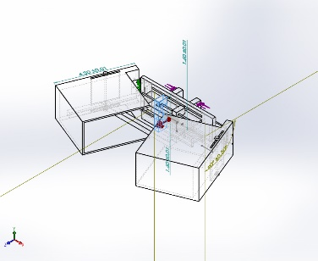 | Solid Body | Mass:0.0342543 kg  Volume:4.39158e-06 m^3  Density:7,800 kg/m^3  Weight:0.335692 N | C:\Users\jvd4618\Downloads\Part1.SLDPRT  Apr 18 22:45:58 2020
Cut-Extrude10  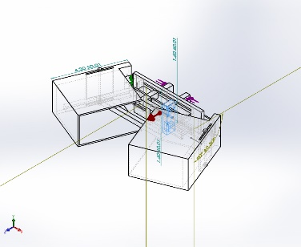 | Solid Body | Mass:0.0342543 kg  Volume:4.39158e-06 m^3  Density:7,800 kg/m^3  Weight:0.335692 N | C:\Users\jvd4618\Downloads\Part1.SLDPRT  Apr 18 22:45:58 2020
Cut-Extrude5  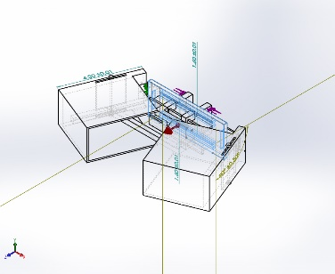 | Solid Body | Mass:0.217292 kg  Volume:2.7858e-05 m^3  Density:7,800 kg/m^3  Weight:2.12947 N | C:\Users\jvd4618\Downloads\Part4.SLDPRT  Apr 18 22:45:59 2020
Chamfer2  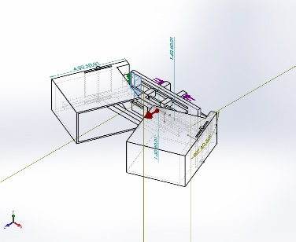 | Solid Body | Mass:0.00941039 kg  Volume:1.20646e-06 m^3  Density:7,800 kg/m^3  Weight:0.0922218 N | C:\Users\jvd4618\Downloads\Part6 (1).SLDPRT  Apr 18 22:45:58 2020
Chamfer2  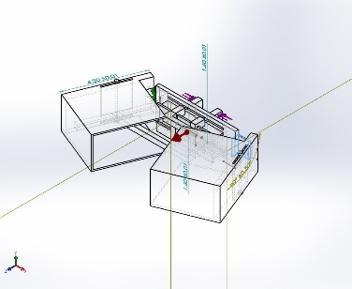 | Solid Body | Mass:0.00941039 kg  Volume:1.20646e-06 m^3  Density:7,800 kg/m^3  Weight:0.0922218 N | C:\Users\jvd4618\Downloads\Part6 (1).SLDPRT  Apr 18 22:45:58 2020
SurfaceCut2  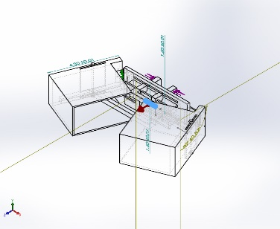 | Solid Body | Mass:0.00307379 kg  Volume:3.94073e-07 m^3  Density:7,800.05 kg/m^3  Weight:0.0301231 N | C:\Users\jvd4618\Downloads\Part7spring3.SLDPRT  Apr 19 01:21:46 2020
Cut-Extrude6  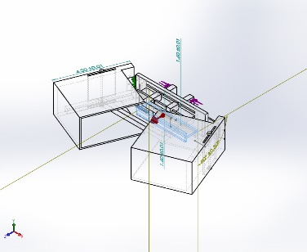 | Solid Body | Mass:0.0581577 kg  Volume:7.45611e-06 m^3  Density:7,800 kg/m^3  Weight:0.569945 N | C:\Users\jvd4618\Downloads\Part9 (2).SLDPRT  Apr 18 22:45:58 2020
Cut-Extrude6   | Solid Body | Mass:0.0581577 kg  Volume:7.45611e-06 m^3  Density:7,800 kg/m^3  Weight:0.569945 N | C:\Users\jvd4618\Downloads\Part9 (2).SLDPRT  Apr 18 22:45:58 2020
Cut-Extrude6  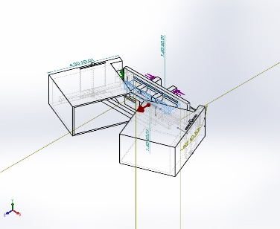 | Solid Body | Mass:0.0581577 kg  Volume:7.45611e-06 m^3  Density:7,800 kg/m^3  Weight:0.569945 N | C:\Users\jvd4618\Downloads\Part9 (2).SLDPRT  Apr 18 22:45:58 2020
Cut-Extrude1  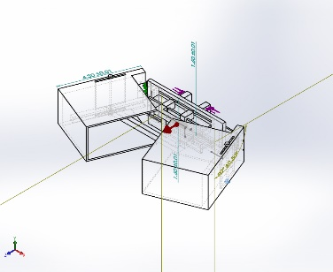 | Solid Body | Mass:9.26831e-05 kg  Volume:3.99496e-08 m^3  Density:2,320 kg/m^3  Weight:0.000908295 N | C:\Users\jvd4618\Downloads\capon.SLDPRT  Apr 18 22:45:58 2020
Cut-Extrude1  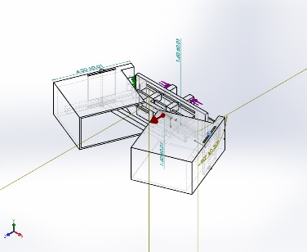 | Solid Body | Mass:9.26831e-05 kg  Volume:3.99496e-08 m^3  Density:2,320 kg/m^3  Weight:0.000908295 N | C:\Users\jvd4618\Downloads\capon.SLDPRT  Apr 18 22:45:58 2020
Cut-Extrude1  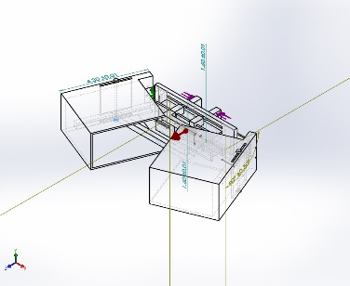 | Solid Body | Mass:9.26831e-05 kg  Volume:3.99496e-08 m^3  Density:2,320 kg/m^3  Weight:0.000908295 N | C:\Users\jvd4618\Downloads\capon.SLDPRT  Apr 18 22:45:58 2020
Cut-Extrude1  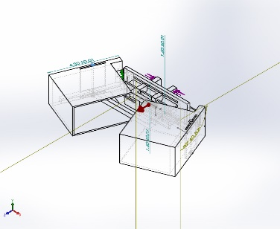 | Solid Body | Mass:9.26831e-05 kg  Volume:3.99496e-08 m^3  Density:2,320 kg/m^3  Weight:0.000908295 N | C:\Users\jvd4618\Downloads\capon.SLDPRT  Apr 18 22:45:58 2020
Boss-Extrude1  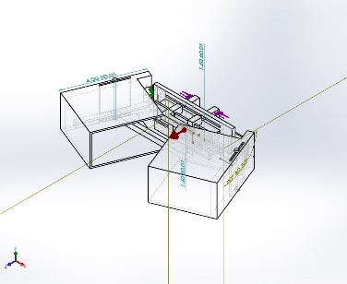 | Solid Body | Mass:0.000353369 kg  Volume:4.53037e-08 m^3  Density:7,800 kg/m^3  Weight:0.00346302 N | C:\Users\jvd4618\Downloads\connection.SLDPRT  Apr 18 22:45:58 2020
Boss-Extrude1  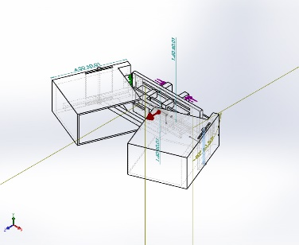 | Solid Body | Mass:0.000353369 kg  Volume:4.53037e-08 m^3  Density:7,800 kg/m^3  Weight:0.00346302 N | C:\Users\jvd4618\Downloads\connection.SLDPRT  Apr 18 22:45:58 2020
Cut-Extrude8  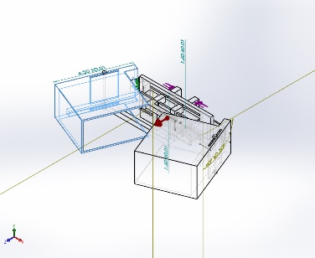 | Solid Body | Mass:0.598082 kg  Volume:7.66771e-05 m^3  Density:7,800 kg/m^3  Weight:5.8612 N | C:\Users\jvd4618\Downloads\flapbox.SLDPRT  Apr 18 22:45:58 2020
Cut-Extrude8  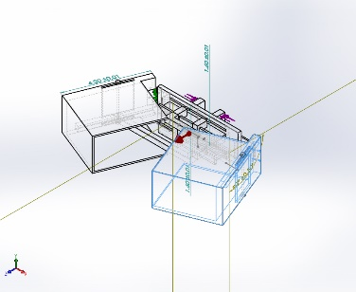 | Solid Body | Mass:0.598082 kg  Volume:7.66771e-05 m^3  Density:7,800 kg/m^3  Weight:5.8612 N | C:\Users\jvd4618\Downloads\flapbox.SLDPRT  Apr 18 22:45:58 2020

Study Properties
Study name | Nonlinear Stainless With Teflon Sliding Parts
Analysis type | Nonlinear - Dynamic
Mesh type | Solid Mesh
Start time | 0 Seconds
End time | 1 Seconds
Time increment | Auto stepping
Large displacement formulation: | On
Update load direction with deflection: | Off
Large strain formulation: | Off
Save data for restarting the analysis | Off
Thermal Effect: | On
Thermal option | Include temperature loads
Zero strain temperature | 298 Kelvin
Solver type | FFEPlus
Incompatible bonding options | Simplified
Control technique: | Force
Iterative technique: | NR(Newton-Raphson)
Integration Method | Newmark
Result folder | SOLIDWORKS document (C:\Users\jvd4618\Downloads)

Units
Unit system: | SI (MKS)
Length/Displacement | mm
Temperature | Kelvin
Angular velocity | Rad/sec
Pressure/Stress | N/m^2

Material Properties
Model Reference | Properties | Components
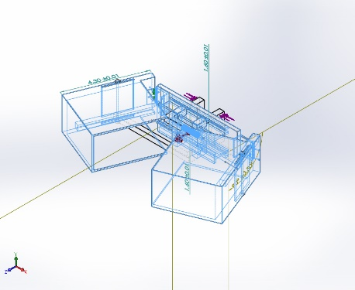 | Name: Stainless Steel (ferritic)  Model type: Linear Elastic Isotropic  Default failure criterion: Max von Mises Stress  Yield strength: 1.72339e+08 N/m^2  Tensile strength: 5.13613e+08 N/m^2  Elastic modulus: 2e+11 N/m^2  Poisson's ratio: 0.28  Mass density: 7,800 kg/m^3  Shear modulus: 7.7e+10 N/m^2  Thermal expansion coefficient: 1.1e-05 /Kelvin | SolidBody 1(Cut-Extrude1)(Assemhinge (1)-4/Part1hingefolder-1),  SolidBody 1(Cut-Extrude1)(Assemhinge (1)-4/Part1hingefolder-5),  SolidBody 1(Chamfer1)(Assemhinge (1)-4/Part2hingebolt-2),  SolidBody 1(Cut-Extrude1)(Assemhinge (1)-5/Part1hingefolder-1),  SolidBody 1(Cut-Extrude1)(Assemhinge (1)-5/Part1hingefolder-5),  SolidBody 1(Chamfer1)(Assemhinge (1)-5/Part2hingebolt-2),  SolidBody 1(Cut-Extrude10)(Part1-3),  SolidBody 1(Cut-Extrude10)(Part1-4),  SolidBody 1(Cut-Extrude5)(Part4-1),  SolidBody 1(Chamfer2)(Part6 (1)-1),  SolidBody 1(Chamfer2)(Part6 (1)-3),  SolidBody 1(SurfaceCut2)(Part7spring3-1),  SolidBody 1(Cut-Extrude6)(Part9 (2)-2),  SolidBody 1(Cut-Extrude6)(Part9 (2)-3),  SolidBody 1(Cut-Extrude6)(Part9 (2)-4),  SolidBody 1(Boss-Extrude1)(connection-1),  SolidBody 1(Boss-Extrude1)(connection-2),  SolidBody 1(Cut-Extrude8)(flapbox-1),  SolidBody 1(Cut-Extrude8)(flapbox-2)
Curve Data:N/A
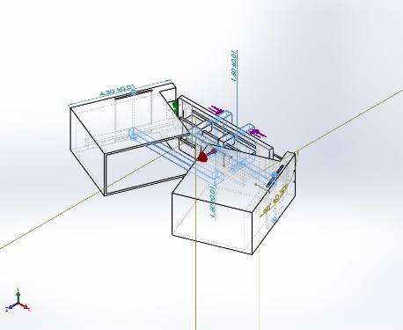 | Name: General Teflon  Model type: Linear Elastic Isotropic  Default failure criterion: Unknown  Tensile strength: 7.58e+06 N/m^2  Elastic modulus: 5.51581e+08 N/m^2  Poisson's ratio: 0  Mass density: 2,320 kg/m^3 | SolidBody 1(Boss-Extrude2)(Bar (3)-1),  SolidBody 1(Boss-Extrude2)(Bar (3)-2),  SolidBody 1(Cut-Extrude1)(JazzBlockAssem-4/Correct Dimensions Gripper Part Sliding Pole Attached to Top Block (1) (2)-1),  SolidBody 1(Cut-Extrude1)(JazzBlockAssem-4/Correct Dimensions Gripper Part Sliding Pole Attached to Top Block (1) (2)-2),  SolidBody 1(Boss-Extrude1)(JazzBlockAssem-4/JazzBlock-1),  SolidBody 1(Cut-Extrude1)(JazzBlockAssem-5/Correct Dimensions Gripper Part Sliding Pole Attached to Top Block (1) (2)-1),  SolidBody 1(Cut-Extrude1)(JazzBlockAssem-5/Correct Dimensions Gripper Part Sliding Pole Attached to Top Block (1) (2)-2),  SolidBody 1(Boss-Extrude1)(JazzBlockAssem-5/JazzBlock-1),  SolidBody 1(Cut-Extrude1)(capon-1),  SolidBody 1(Cut-Extrude1)(capon-2),  SolidBody 1(Cut-Extrude1)(capon-3),  SolidBody 1(Cut-Extrude1)(capon-4)
Curve Data:N/A

Loads and Fixtures
Fixture name | Fixture Image | Fixture Details
Fixed Hinge-1 | 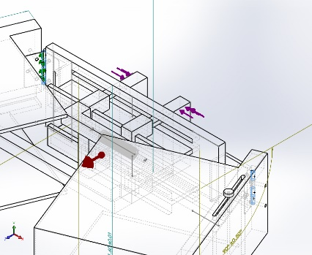 | Entities: 9 face(s)  Type: Fixed Hinge
Resultant Forces
Components | X | Y | Z | Resultant
Reaction force(N) | 4.75153e-06 | 4.43608e-08 | -4.14393e-05 | 4.17109e-05
Reaction Moment(N.m) | 0 | 0 | 0 | 0

Load name | Load Image | Load Details
Force-1 | 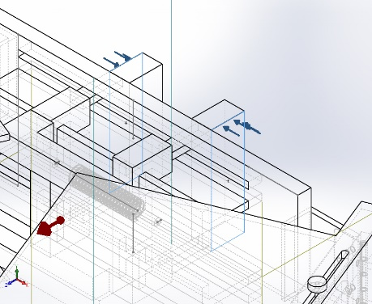 | Entities: 2 face(s)  Type: Apply normal force  Value: 1 lbf
Gravity-1 | 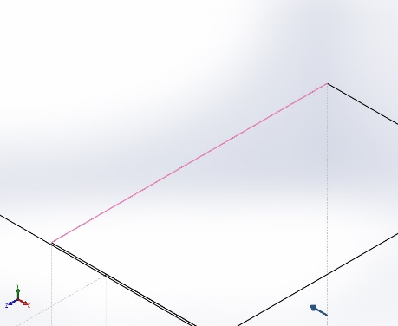 | Reference: Edge< 1 >  Values: 0 0 1.63  Units: m/s^2

Connector Definitions
No Data

Contact Information

Contact | Contact Image | Contact Properties
Global Contact | 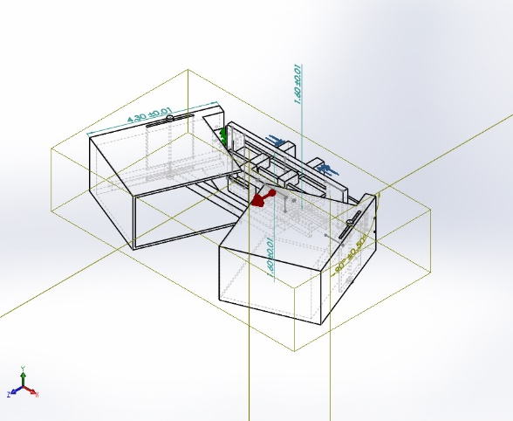 | Type: Allow Penetration  Components: 1 component(s)

Mesh information
Mesh type | Solid Mesh
Mesher Used: | Curvature-based mesh
Jacobian points | 4 Points
Maximum element size | 0.64871 in
Minimum element size | 0.129742 in
Mesh Quality Plot | High
Remesh failed parts with incompatible mesh | Off

Mesh information - Details
Total Nodes | 34439
Total Elements | 16990
Maximum Aspect Ratio | 438.05
% of elements with Aspect Ratio < 3 | 26
% of elements with Aspect Ratio > 10 | 15
% of distorted elements(Jacobian) | 0
Time to complete mesh(hh;mm;ss): | 00:00:03
Computer name: | CEAS-CAE-I12
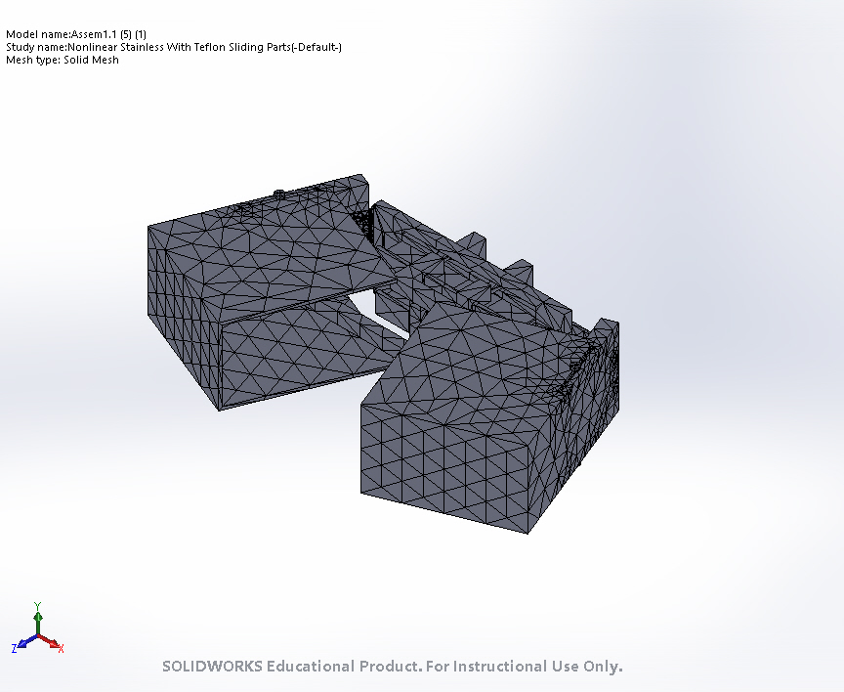

Sensor Details
No Data

Resultant Forces

Reaction forces
Selection set | Units | Sum X | Sum Y | Sum Z | Resultant
Entire Model | N | 4.75153e-06 | 4.43608e-08 | -4.14393e-05 | 4.17109e-05

Reaction Moments
Selection set | Units | Sum X | Sum Y | Sum Z | Resultant
Entire Model | N.m | 0 | 0 | 0 | 0

Beams
No Data

Study Results

Name | Type | Min | Max
Stress1 | VON: von Mises Stress at Step No: 327(8.52691e-315 Seconds) | 7.285e-01 N/m^2  Node: 2619 | 7.260e+10 N/m^2  Node: 283
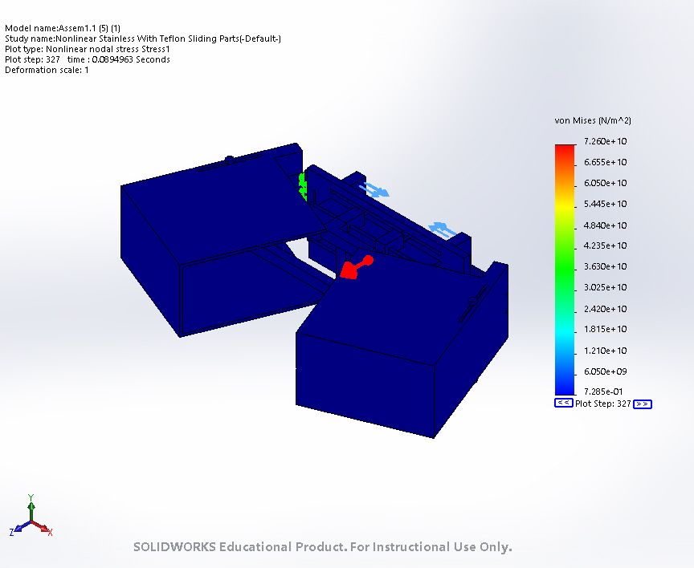
Assem1.1 (5) (1)-Nonlinear Stainless With Teflon Sliding Parts-Stress-Stress1

Name | Type | Min | Max
Displacement1 | URES: Resultant Displacement at Step No: 327(8.52691e-315 Seconds) | 4.684e-10 mm  Node: 6036 | 5.841e+01 mm  Node: 7504
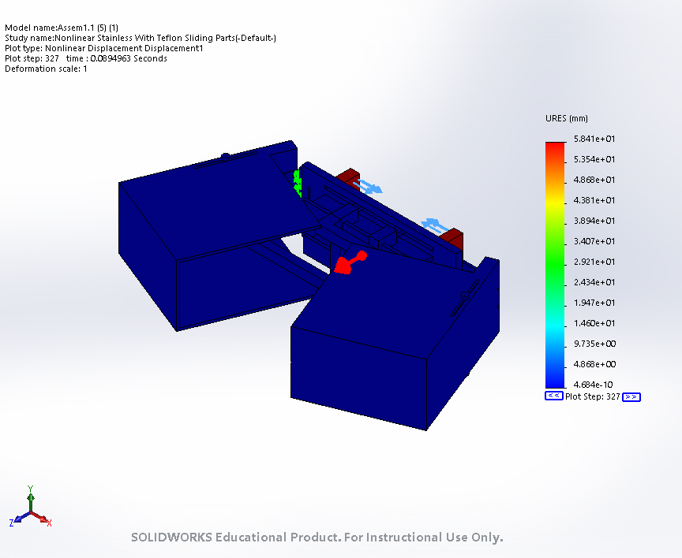
Assem1.1 (5) (1)-Nonlinear Stainless With Teflon Sliding Parts-Displacement-Displacement1

Name | Type | Min | Max
Strain1 | ESTRN: Equivalent Strain at Step No: 327(8.52691e-315 Seconds) | 5.476e-12  Element: 1429 | 4.778e-01  Element: 470
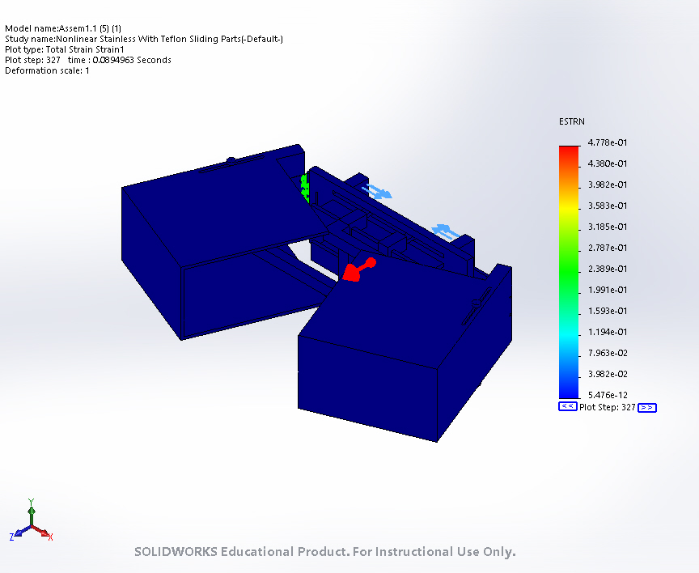
Assem1.1 (5) (1)-Nonlinear Stainless With Teflon Sliding Parts-Strain-Strain1

Conclusion

